Experiment 1
- Connect two hosts back-to-back with a cross over cable. Assign IP addresses, and see whether they are able to ping each other.

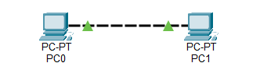
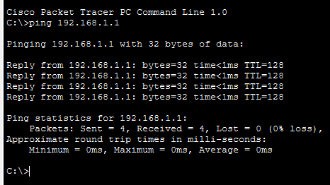

- Create a LAN (named LAN-A) with 3 hosts using a hub.

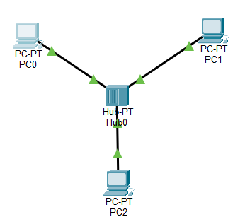
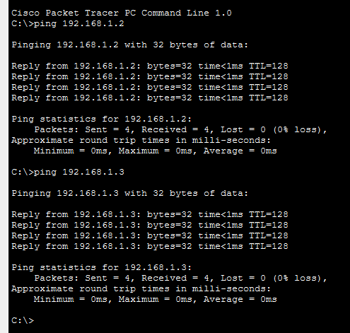

- Create a LAN (named LAN-B) with 3 hosts using a switch. Record contents of the ARP Table of end hosts and the MAC Forwarding Table of the switch. Ping each pair of nodes. Now record the contents of the ARP Table of end hosts and the MAC Forwarding Table of the switch again.
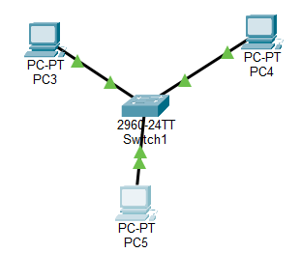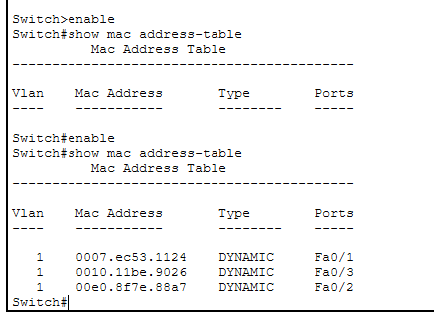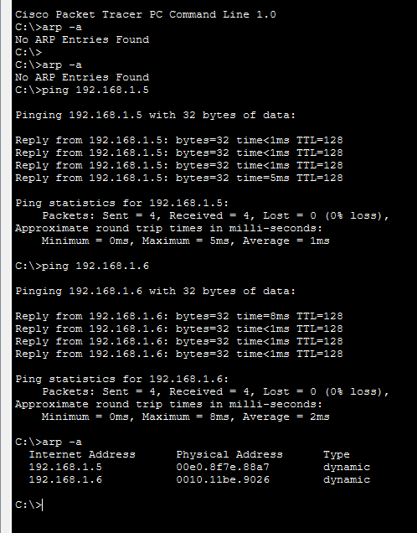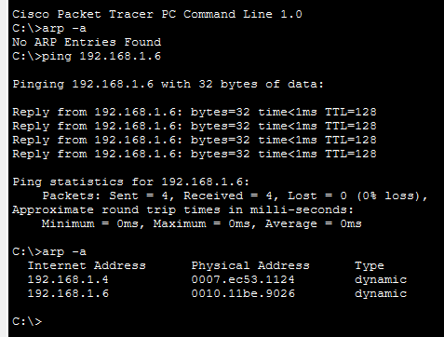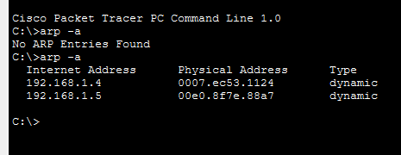

- Connect LAN-A and LAN-B by connecting the hub and switch using a cross-over cable. Ping between each pair of hosts of LAN-A and LAN-B. Now record the contents of the ARP Table of end hosts and the MAC Forwarding Table of the switch again.

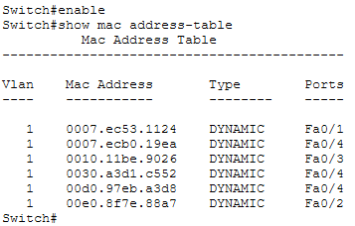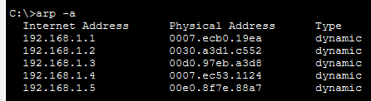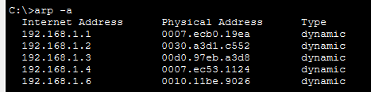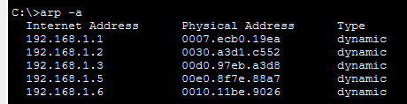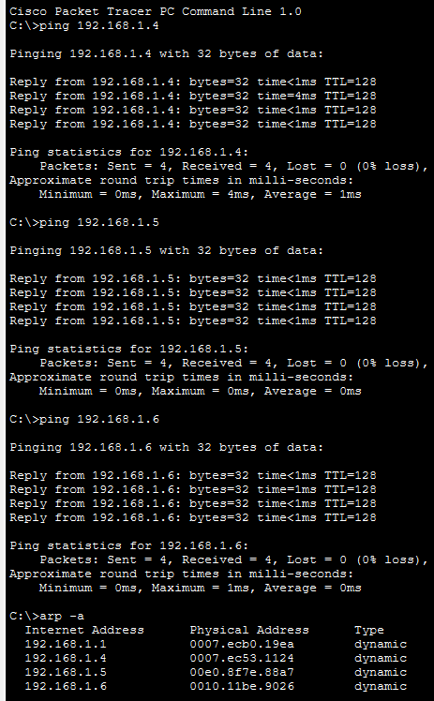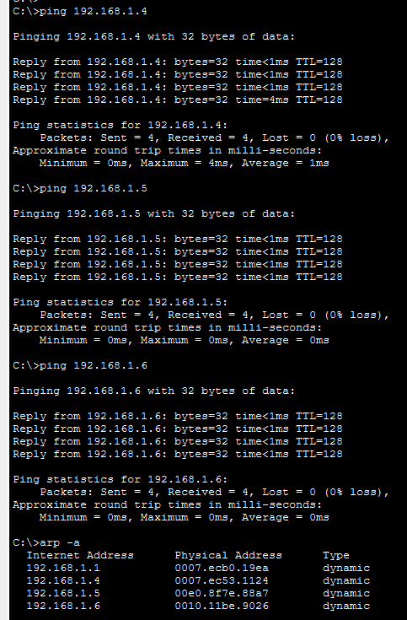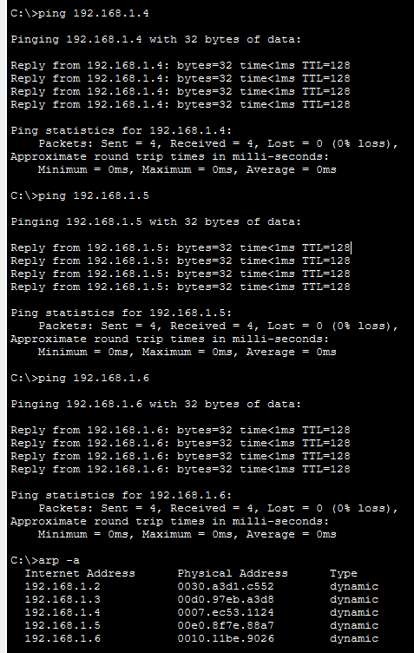

Experiment 2
- Create a LAN (named JU-Main) with three hosts connected via a layer-2 switch. Connect the switch to a router. Assign IP addresses to all the hosts and the router interface connected to this LAN from network address 192.168.120.0/24. Configure default gateway of each hosts as the IP address of the interface of the router, which is connected to the LAN.
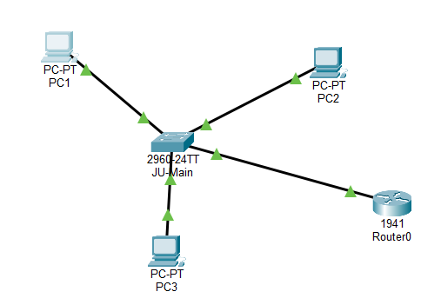
2. Create another LAN (named JU-SL) with three hosts connected via a layer-2 switch. Connect this switch to another router (Cisco 1818). Assign IP addresses to all the hosts and the router interface connected to this
LAN from network address 192.168.130.0/24. Configure default gateway of each hosts as the IP address of the interface of the router which is connected to the LAN.
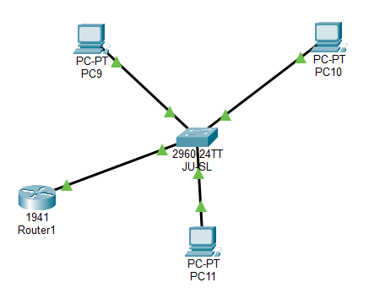
3. Connect the two routers through appropriate WAN interfaces. Assign IP addresses to the WAN interfaces
from network 192.168.150.0/24.
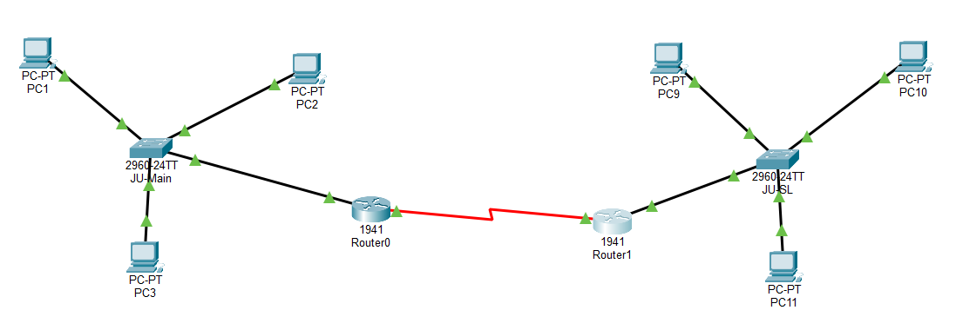
4. Add static route in both of the routers to route packets between two LANs.
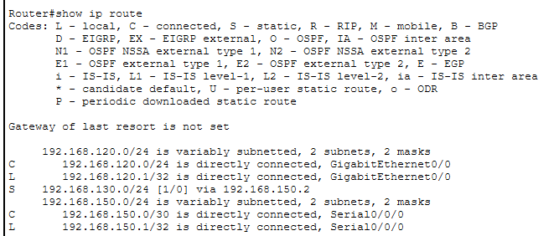
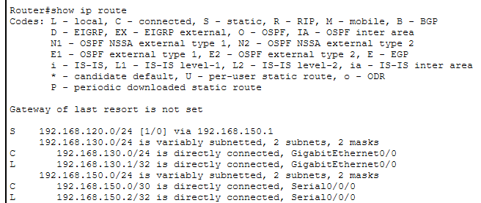

5. Test the configuration by sending ping requests from hosts in each LAN.


